**Inventory Management**

This module provides centralization of your most basic and necessary warehouse functions. With it, you’re able to see complete inventory details like stock levels, product history and other product specifications. This data syncs to all other parts of your system, so all your functions can run using the same information. This is an important factor in breaking down data silos within your business operations. Working with the same information ensures collaboration between your teams to a much higher degree than if they were to work with their individual systems.

Speaking of collaboration, many systems offer collaborative inventory, [which allows vendors to manage your inventory remotely](https://www.selecthub.com/inventory-management/vendor-managed-inventory-systems/). Vendor managed inventory (VMI) is a great solution for those in long-term business relationships. If you know that you’ll be needing your suppliers’ product sent to your customers on a recurring basis, VMI is perfect for you. Let your vendor manage these recurring deliveries and stress about one less thing.

You may also be interested in automatic shortage reports so you can respond to any ensuing issues as quickly as possible. Don’t wait until your phone is ringing off the hook to deal with unfortunate inventory mishaps. Alerts and reports give you the agency and response-time needed to handle such events. Inventory control software can also help you build an e-commerce presence.

 Product Categorization  
 Product Measurement  
 Product History  
 Stock Inquiries  
 Cycle Counting  
 Collaborative Inventory  
 Automatic Stock-out Reports  
 Vendor-Managed Inventory  
 e-Commerce

**Inventory Tracking**

Tracking your inventory is important at every stage. Many systems allow you to track your inventory by serial numbers, RFID tags, barcodes and other IDs. These tools make it easy to quickly process inventory data when it first makes its way into your warehouse. They also provide an audit of all inventory movement. This is especially important for industries that deal in perishables or consumables. If you ever find yourself needing to recall a certain product, traceability allows you to recall only the products affected. Without traceability, you risk having to recall all items, affected or not, and losing massive amounts of revenue.

Some systems provide traceability that’s built with pick and putaway in mind. First, a quick scan of the tracking tags tells you the location of stock in your warehouse. Then, your system uses that information to optimize the pick and putaway processes by creating efficient routes for your workers. Reduce movement without purpose in your warehouse to boost productivity and cut labor costs.

 Product Tracking  
 Advanced Inventory Tagging  
 Audit Trail

**Transfer Management**

Enterprise businesses that manage multiple sites have the advantage of moving their product to where it’s most valuable. Bundling or kitting your products can be attractive to customers, especially during certain times of the year. In order to do this most effectively, you’ll want a system equipped with transfer management.

Transfer management enables you to track your inventory as it moves to different sites and facilitates the overall transfer process. Some modules offer specialized systems like pick-to-light and voice picking to facilitate this. These systems can help guide and direct your workforce to reduce any confusion and streamline their efforts.

 Multi-Location Tracking  
 Stock Transfer  
 Order Picking  
 Kitting and Product Bundling  
 Voice Picking  
 Pick-to-Light (PTL)

**Purchasing**

Purchasing is an incredibly important feature to any warehouse that heavily relies on vendor goods to produce their own. This feature mainly works to help users create and manage purchase orders (POs). Many systems include templates that automatically populate with existing data from other parts of the system. Users may also find it helpful to email suppliers directly from their inventory control system, which reduces the amount of time spent switching screens.

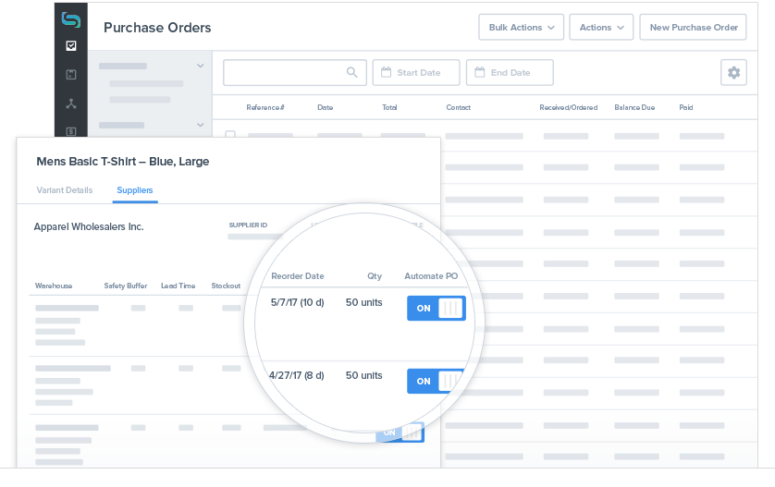

Some systems, like Stitch Inventory seen here, allow users to automate the purchasing order process.

Some inventory software allow users to add items to the PO through barcode scanners. You may also wish to opt for an inventory system that automatically generates POs when an item is low in stock to prevent a stock outage. Purchasing also involves receiving partial orders and tracking backorders.

 Purchase Order  
 Bulk POs  
 Partial Receiving  
 Supplier Management  
 Backordering

[**Compare Top Inventory Management Software Leaders**](https://pmo.selecthub.com/ims-report-site-vers/)

**Shipping**

Having good shipping capability is extremely important to overall order fulfillment and customer satisfaction levels. It’s good to choose a system that can automate much of the process to reduce any errors your customers may experience, such as late deliveries or incorrect packages.

Standard shipping tools typically include the ability to print product labels and barcodes. You may also desire a solution that integrates with top third-party providers like UPS and FedEx. But there are more advanced features of inventory management systems like the ability to dispatch orders as multiple shipments. This ensures your customers get their in-stock goods quickly with backordered items sent at a later time. Some systems allow you to ship by lot IDs, which is great for [FIFO and LIFO](https://www.businessnewsdaily.com/5514-fifo-lifo-differences.html) shipments.

 Labeling  
 Multi-Carrier Shipping  
 Multiple Shipment Orders  
 Shipment by ID

**Order Management**

Most vendors offer an inventory management system that can help you manage your sales orders. These tools allow users to customize pricing, send quotes, track orders and manage returns. Some advanced systems sync orders with inventory levels, mark items for shipment, support multichannel sales and make auto-adjustments to maintain profitability. Order management is an essential feature to increasing and maintaining customer satisfaction.

 Order Tracking  
 Sales Order  
 Quotations  
 Order Editing  
 Customer Pricing  
 Multichannel Sales  
 Returns

**Reporting and Analytics**

Analytics and reporting are excellent tools to have on hand as you plan to grow your business. Analytics tools [evaluate patterns in your processes](https://www.selecthub.com/inventory-management/10-important-inventory-management-metrics-kpis/) to forecast future demand and sales. Predicting demand is a way to reduce safety stock and carrying costs. [Keeping inventory around simply for safety’s sake is no longer necessary](https://www.entrepreneur.com/article/220631) when you have great insights into how much you’ll actually need.

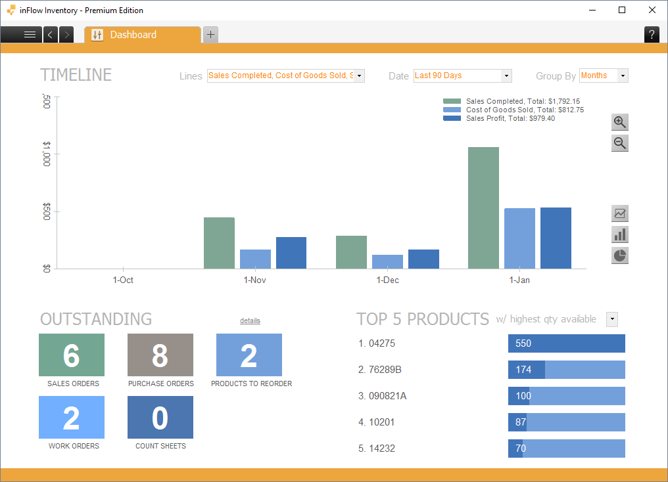

Many systems, like Inflow Inventory, offer easy to understand dashboards to visualize your data.

Analytics also informs you of when demand may be higher than expected, like during certain holidays. Use this data to prevent stock outages, which could result in a missed opportunity to grow your business. Reporting provides this data in ways that are easy to understand and share. These might include specialized PDFs or inbuilt dashboards. You might have the best insights in the company, but without an effective way to share them, they won’t be much use to you. Many tools allow users to also drill down a report to find the level of information necessary for their function.

 Dashboards  
 Customized Reports  
 Report Integration  
 Drill-Down

**Deployment**

Since not every system offers both methods of deployment, you’ll have to consider which is best for your company before you shortlist. [Cloud-based products](https://www.selecthub.com/inventory-management/cloud-based-inventory-management-top-solutions/) typically have fewer sunk costs, offer better visibility and maintain a backup of your data. But many companies prefer on-premise due to privacy concerns or industry compliance standards. There are also [several types of cloud deployment methods](https://www.selecthub.com/cloud-technology/top-cloud-hosting-requirements/) like SaaS, PaaS and IaaS. Some products may offer you deployment options that are more specified, so it’s important to understand the differences.

 On-premise  
 Cloud-based

**Mobile Support**

This aspect affects what hardware you’ll be managing your processes on and if you’ll be able to do it remotely. Many systems offer a mobile website, which enables users to access the system from any desktop. If you utilize tablets, phones or other mobile devices, check to see if a vendor offers a native application. Mobile support is often OS specific, so it’s important to keep that in mind as well. While most vendors try to support all popular platforms, it’s not a universal concern. So it’s always important that the inventory app you invest in can run on your existing hardware.

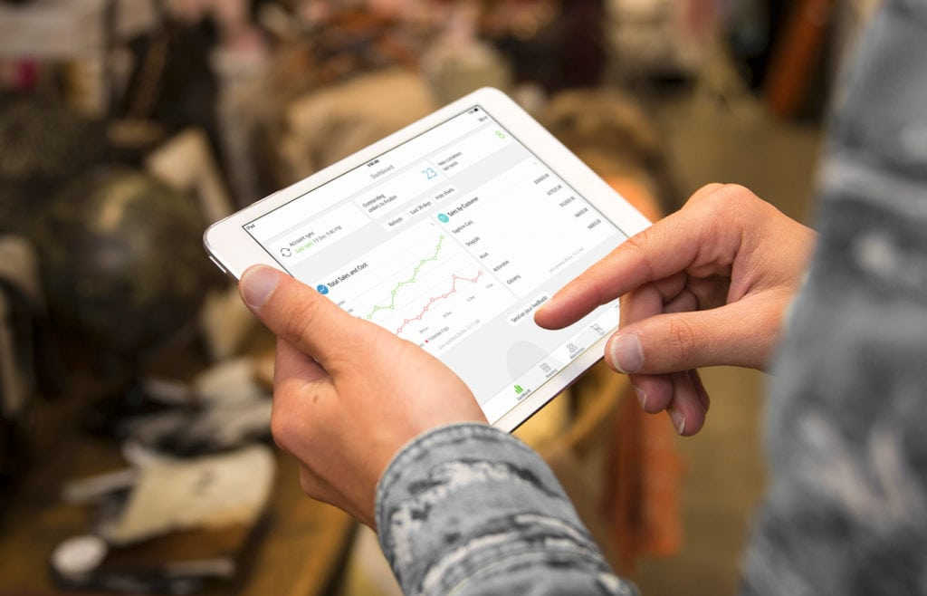

TradeGecko’s mobile app is specifically designed for Apple devices. A great choice for companies already using iOS.

 Native Application  
 Mobile Website  
 Operating System

**Integration**

If you use multiple systems for your business, it’s important they integrate well. It could be beneficial to integrate your other supply chain systems, [CRM and e-Commerce platform](https://www.selecthub.com/customer-relationship-management/crm-ecommerce/). Centralizing business functions that used to only exist as separate processes is one of the greatest benefits to business software. If your systems can’t share information freely, you’re not getting the most from them.

 Integration and Synchronization  
 API/Web Service

[**Get our Inven**](https://pmo.selecthub.com/inventory-management-requirements/)